FIFO PROBLEM STATEMENT

1A) Basic FIFO Testcase :-
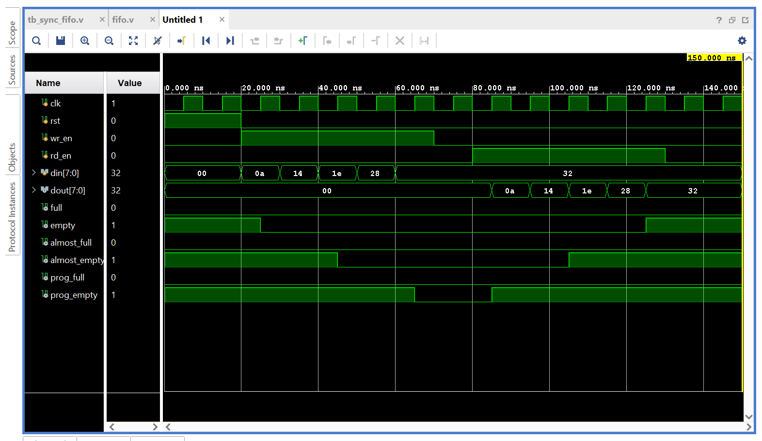

1b) Test case 2 : In this test case, we continuously write data into the FIFO until it becomes full.
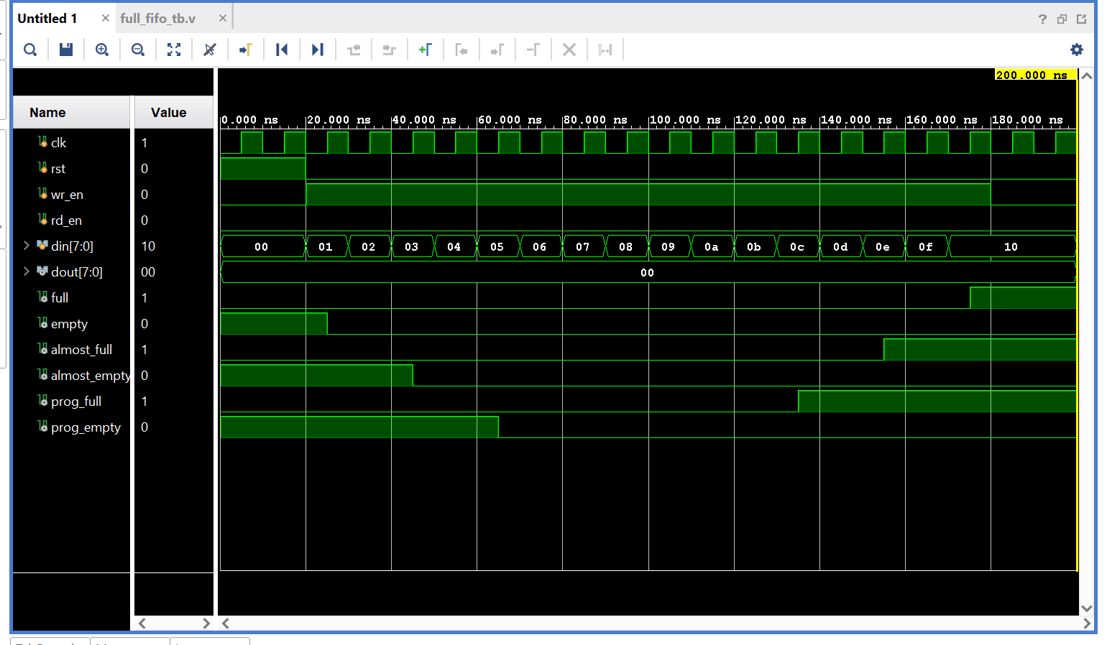

1c) Test Case 1C - Empty and Programmable Empty Flag Verification :
In this test case, five data values (10, 20, 30, 40, 50) are written into the FIFO and then read sequentially. As the FIFO occupancy decreases, the prog_empty flag becomes HIGH when the count reaches the programmed threshold of 4 or less. The almost_empty flag becomes HIGH when only one data word remains, and the empty flag becomes HIGH when all the data has been read.
Waveform Observation: The waveform shows the data being written and read in the same order. The prog_empty, almost_empty, and empty flags are asserted at their respective conditions, verifying the correct empty-side status indication.
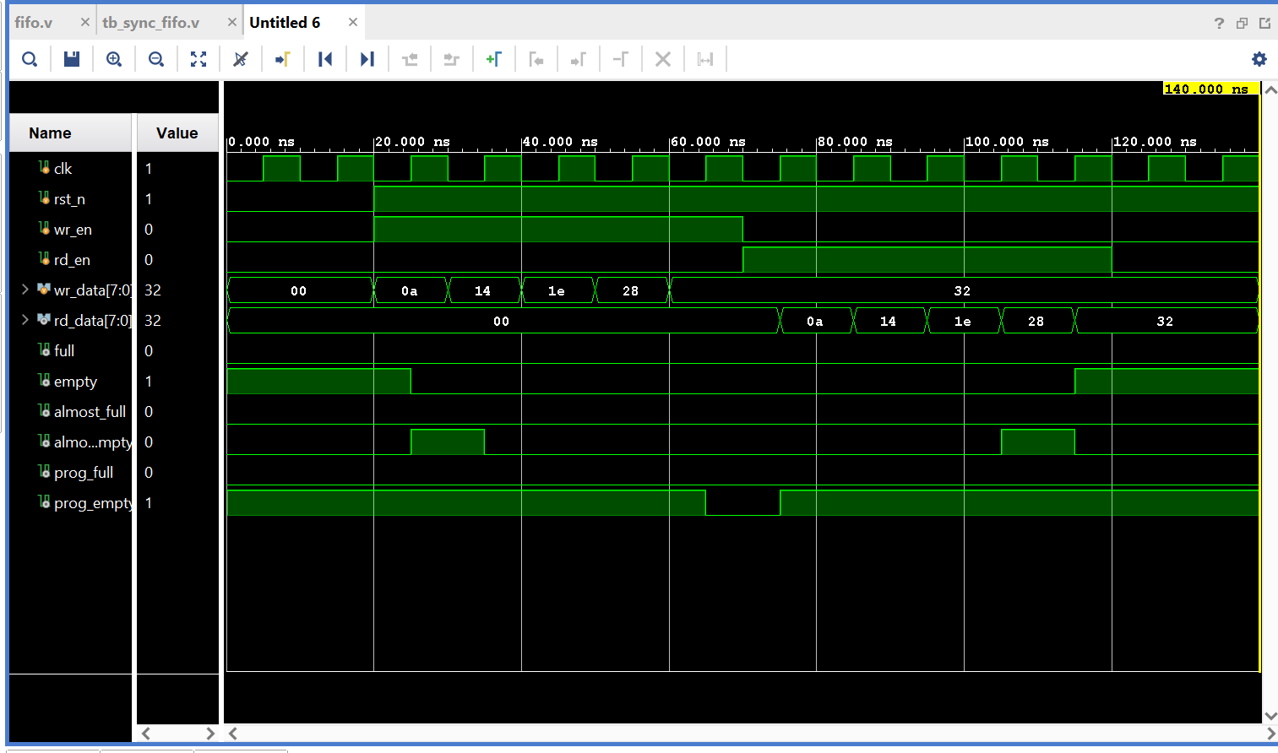

1d)Test case 1D - In this test case, the FIFO is first filled with 16 data values from 00 to 0F. Once the FIFO becomes full, an additional write operation is attempted. Since the full flag is HIGH, the additional data is not accepted. The FIFO is then read sequentially until all 16 data values are removed. Finally, an additional read operation is attempted when the FIFO is empty.
The waveform shows the data being written from 00 to 0F and the full flag becoming HIGH when the FIFO reaches its maximum depth. The extra write operation with data 64 is not accepted. During the read operation, the stored data is read sequentially and the empty flag becomes HIGH after the last data is read. The additional read operation while the FIFO is empty is not accepted.
